Network Availability Monitoring (NAM) Ping Set-up

## Pre-requisites

Ensure that there is at least one Synthetic ActiveGate present and operational.

Ensure that there is a Private Synthetic Location defined.

## Steps

<https://docs.dynatrace.com/docs/observe/digital-experience/synthetic-monitoring/network-availability-monitors/create-a-nam-monitor#nam-api>

1. Select **Synthetic - Network availability monitors.**URL is enabled with adding ui/entity/list/multiprotocol_monitor to the end of the Dynatrace URL e.g.   
   Tenant Specific URL - [https://dxcdynatrace.sso.eu.platform.dxc.com/e/b43c7a32-26d6-4698-a216-300bdd5ab7e4/**ui/entity/list/multiprotocol_monitor**](https://dxcdynatrace.sso.eu.platform.dxc.com/e/b43c7a32-26d6-4698-a216-300bdd5ab7e4/ui/entity/list/multiprotocol_monitor)
2. Select Create a Network Availability Monitor

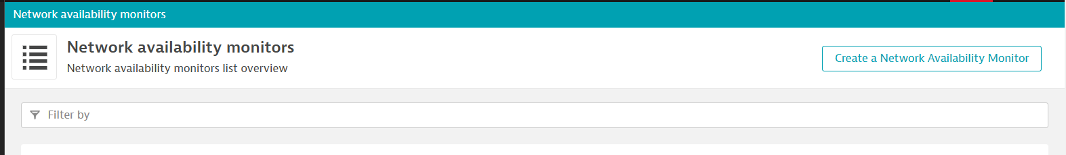

1. Enter Monitor name.

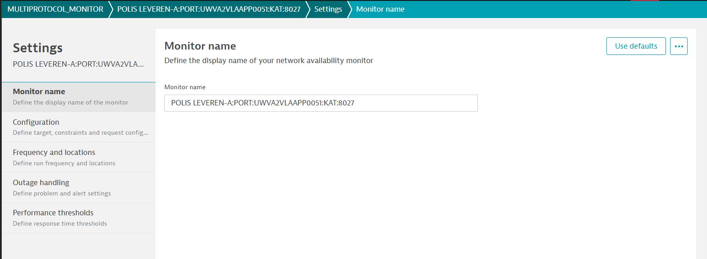

Save the config.

1. Click the configuration.

Enter the Monitor description: - **SERVERName**-ping.

Add Step

Step name: -

Step 1 ping

Request type: -

ICMP

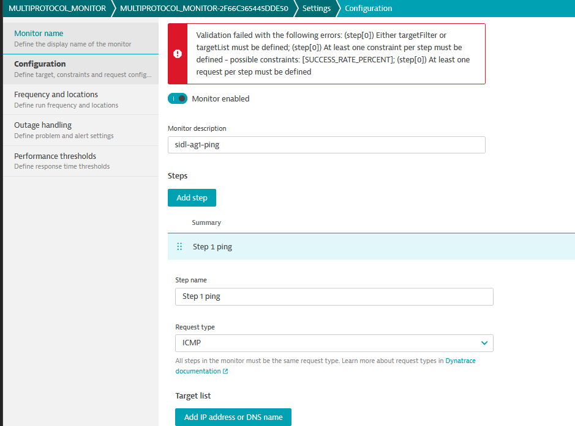

1. Add IP Address or DNS name, by pressing “Add IP address or DNS” – recommended to use the IP address to avoid DNS lookup issues. More than 1 target can be added.

e.g. Target address: -

172.30.176.111

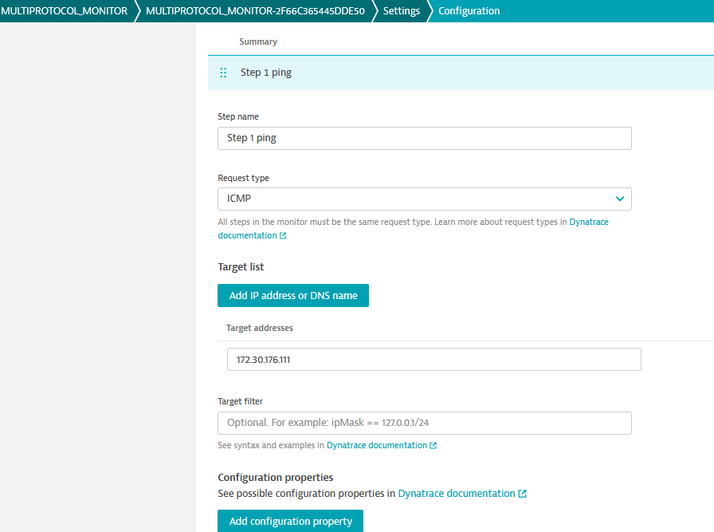

1. Review Configuration Properties available

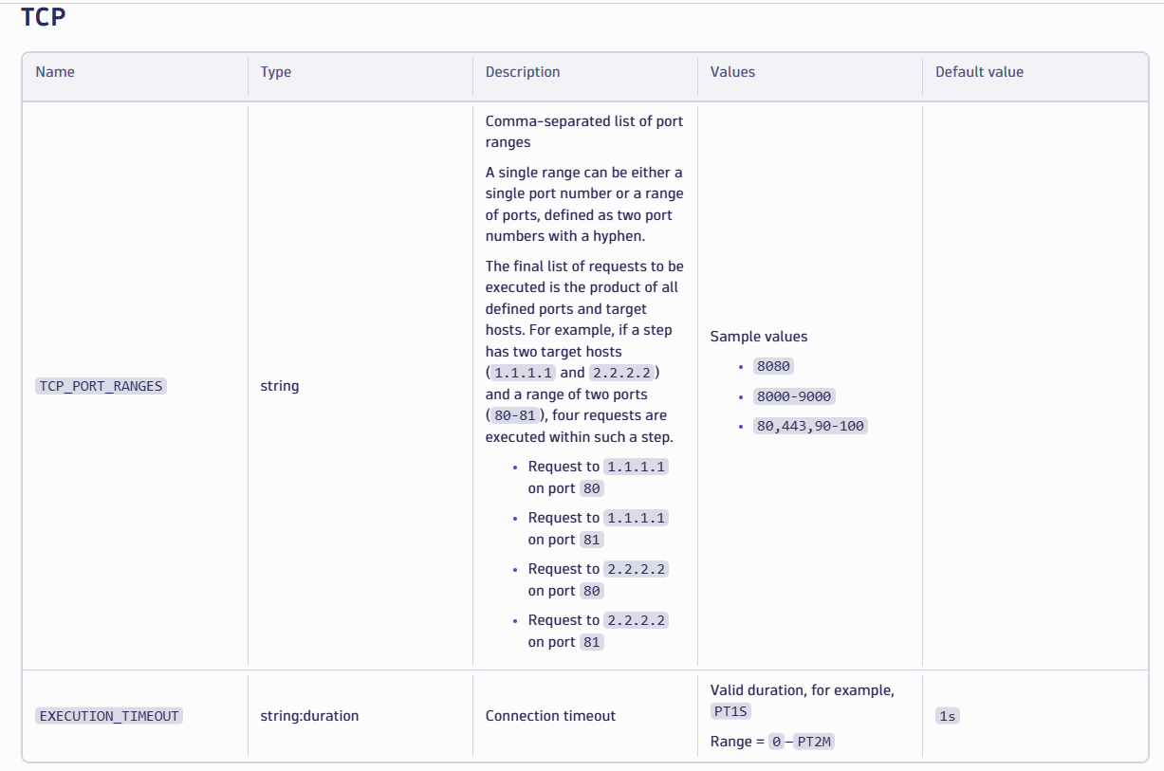

1. Add configuration Property.

For ICMP monitor these properties and values are:   
“property key name” : “value”

"ICMP_NUMBER_OF_PACKETS": "4",

"ICMP_PACKET_SIZE": "32",

"ICMP_TIMEOUT_FOR_REPLY": "PT2S"

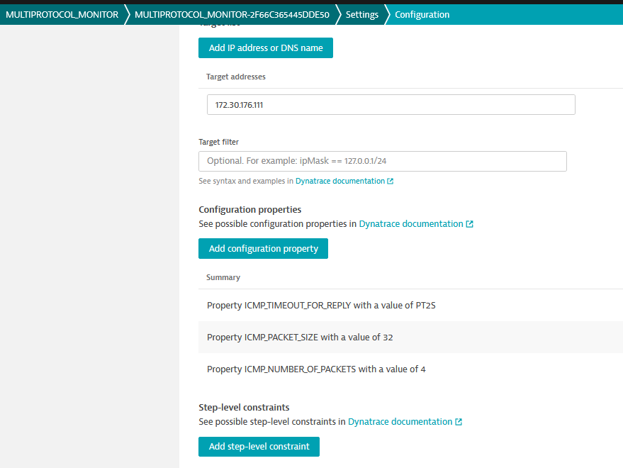

Details for one of the properties:  
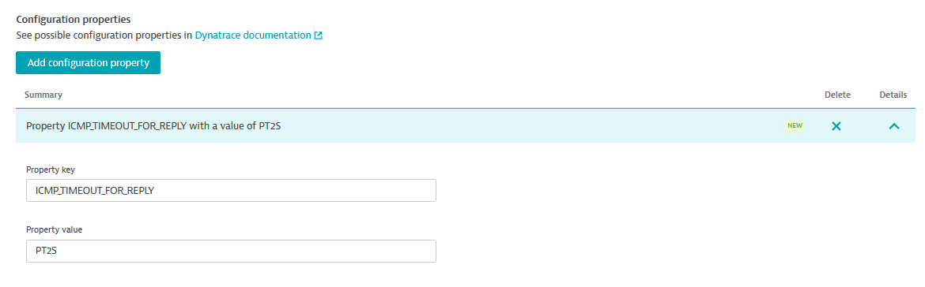

1. Review Step Level constraints  
   IMAGE from Docs
2. Add Step-level constraints.  
   Constraint Type is SUCCESS_RATE_PERCENT
3. Add Step-level constraint properties:  
   For SUCCESS_RATE_PERCENT constraint the values are:  
   “property key” : “Property value”  
   "value": "100"  
    "operator": ">="  
     
   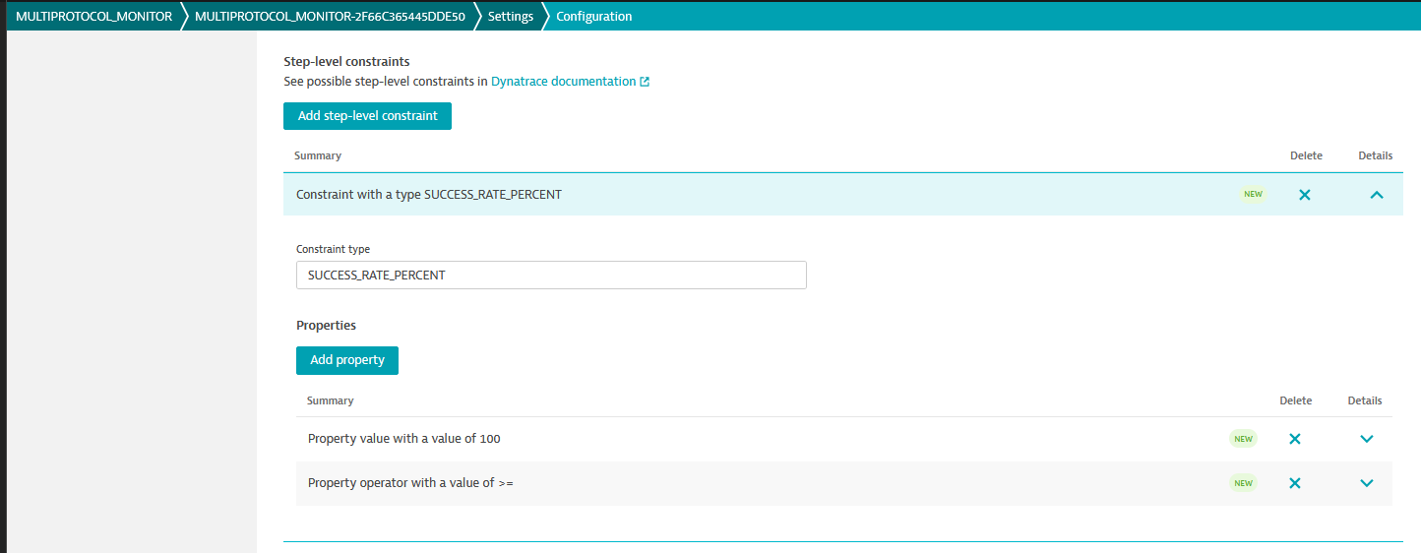  
     
   Expanding a value:  
   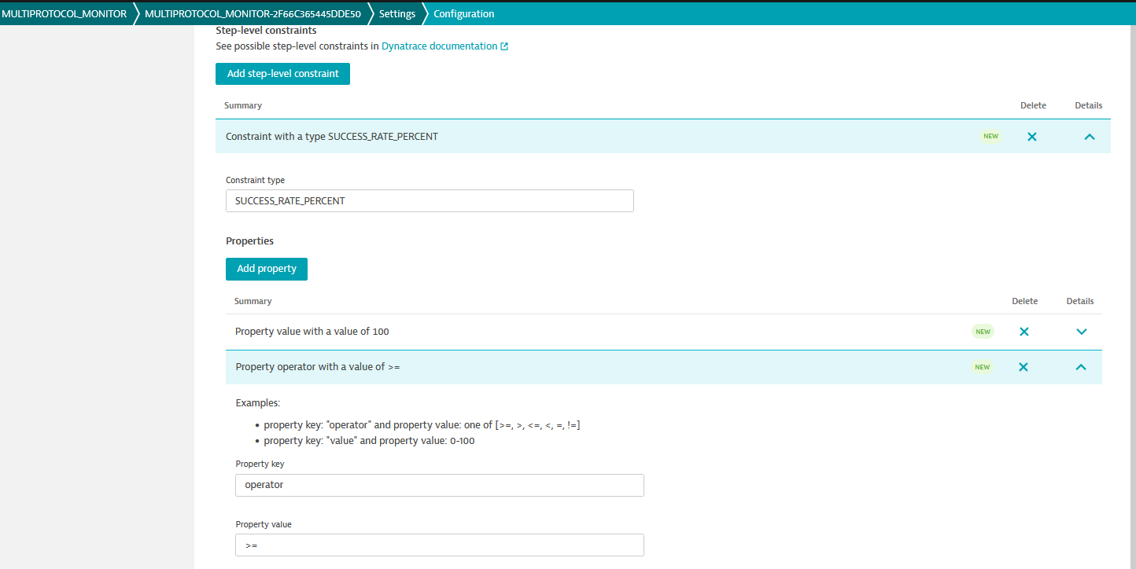
4. Add Resouce constaint type: ICMP_SUCCESS_RATE_PERCENT  
   ICMP values are:  
   "operator": ">="  
    "value": "50"  
     
   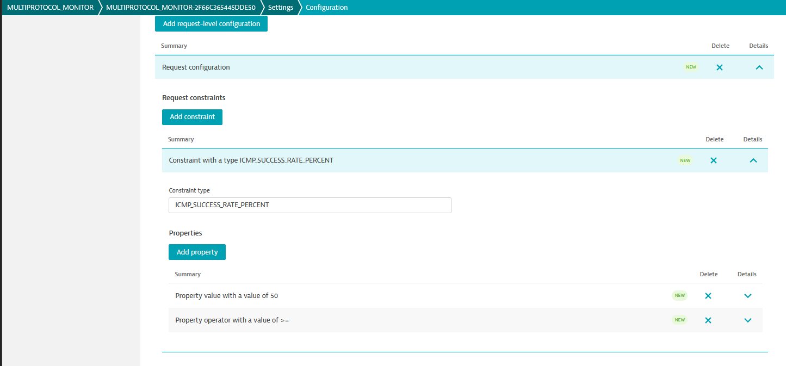
5. Save the changes
6. Select the Frequency and locations. Pick a private synthetic location from the list.

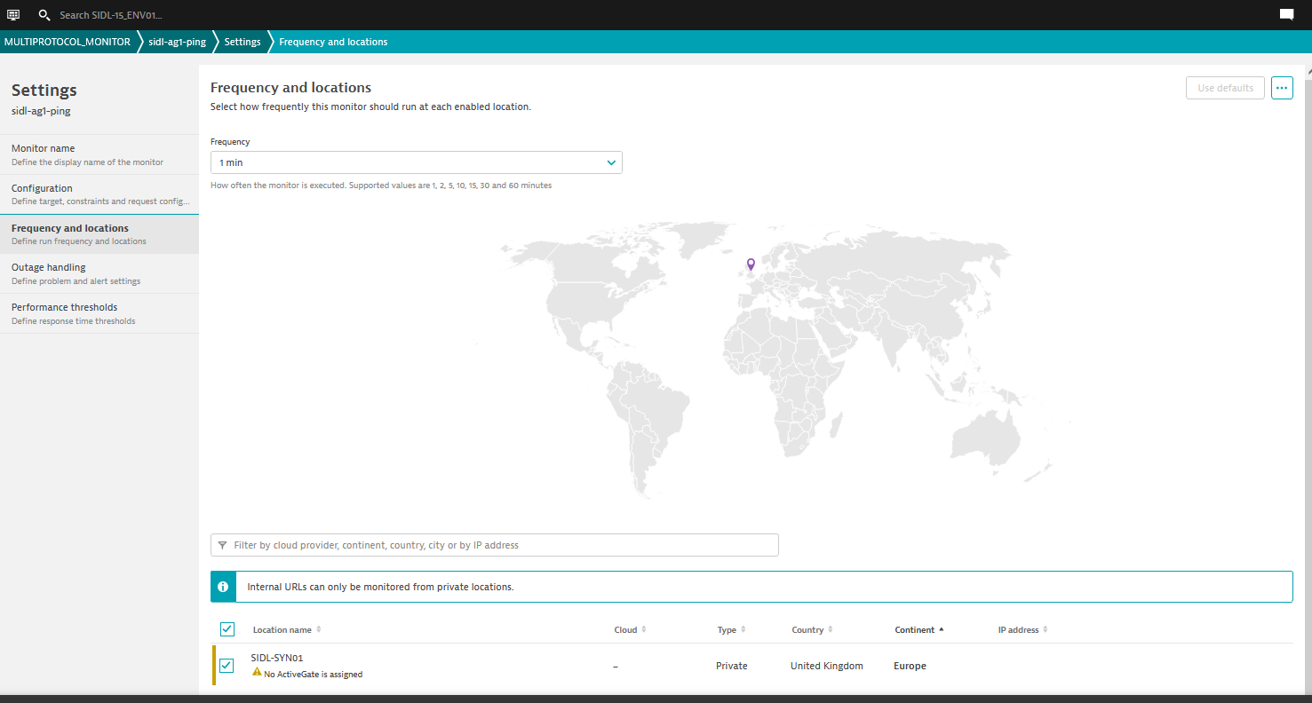

1. Set up the Outage handling.

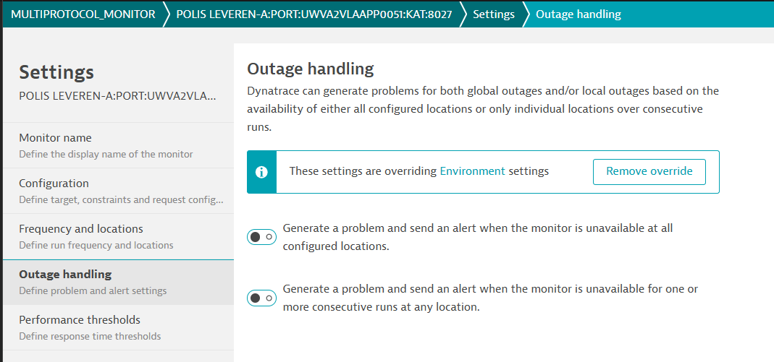

1. Set up the Performance threshold.

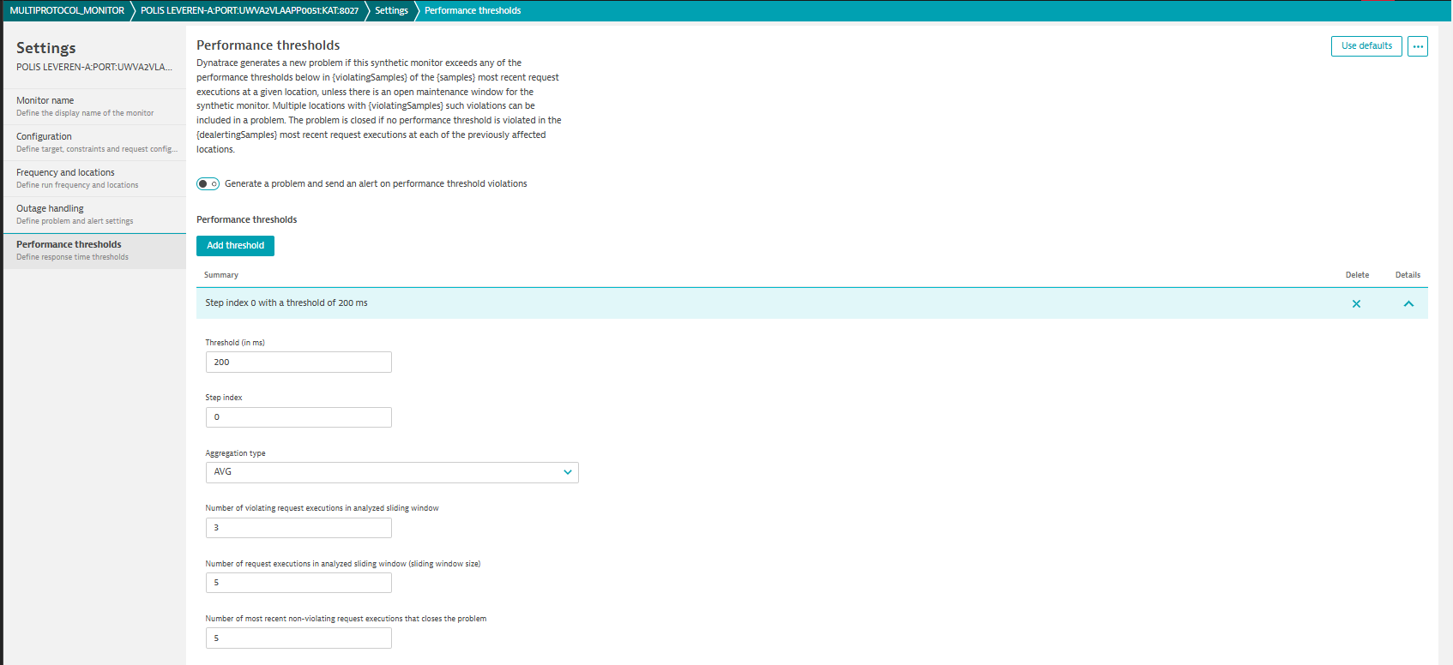

1. Check ping output is received.  
   Initially this will show no data

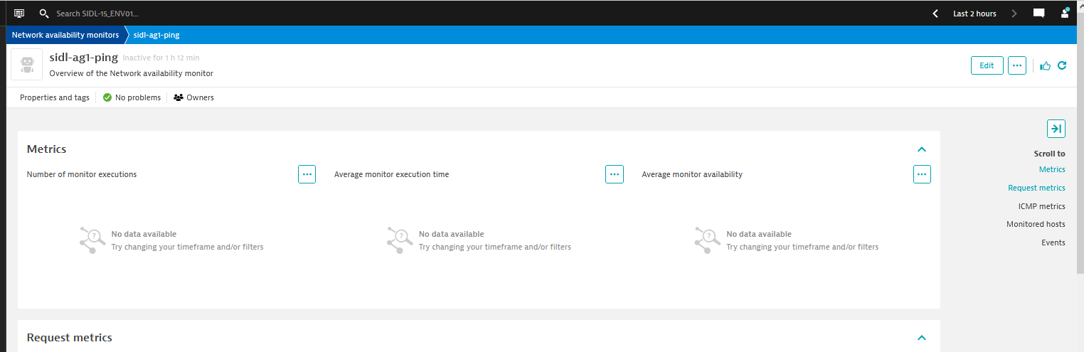  
  
 After some time, this should have more data:  
